# Upload a Video to YuJa and Edit the Captions

1. Login to Brightspace and go to your course. Once in your course, go to the blue navbar and click on **More🡪Course Tools** (1)**🡪YuJa Video Library** (2).

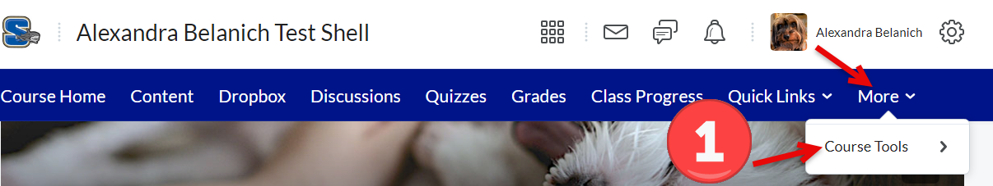

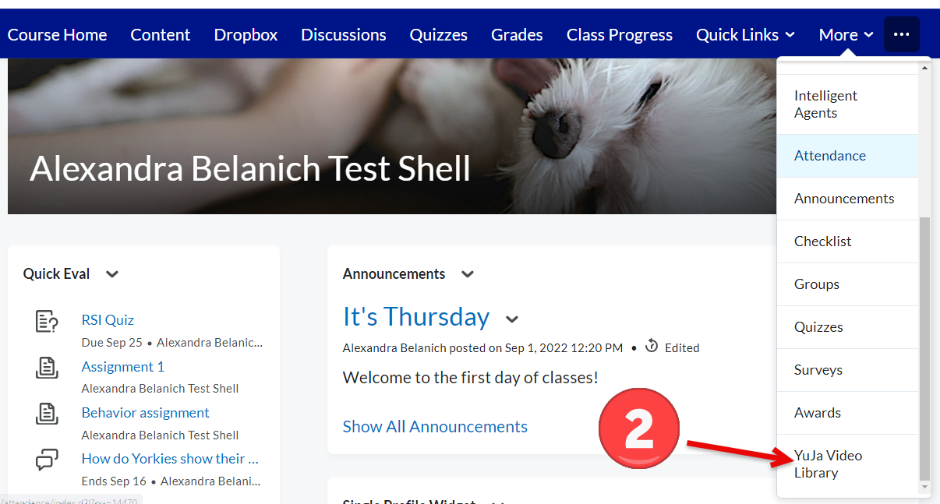

1. Once in YuJa, make sure that you are in **My Media**.  
   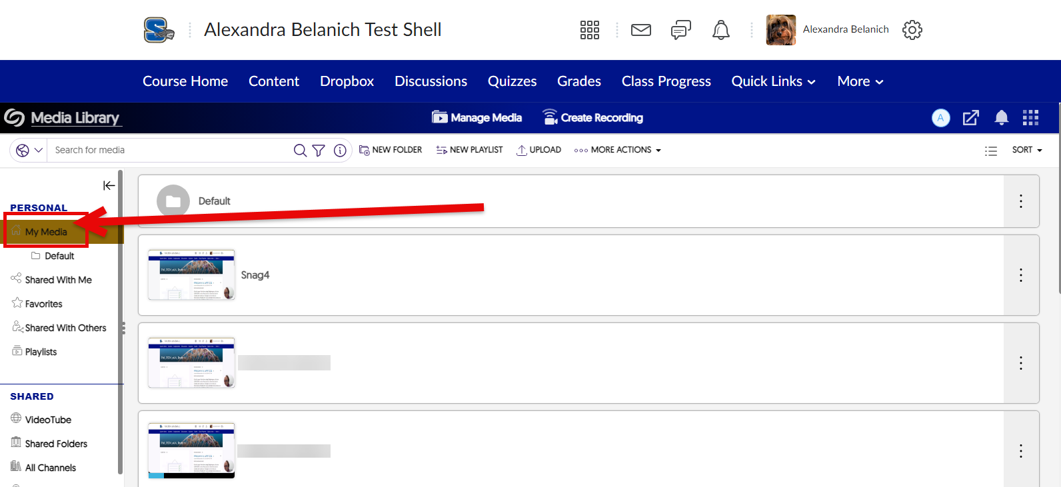
2. Click on **Upload**.   
   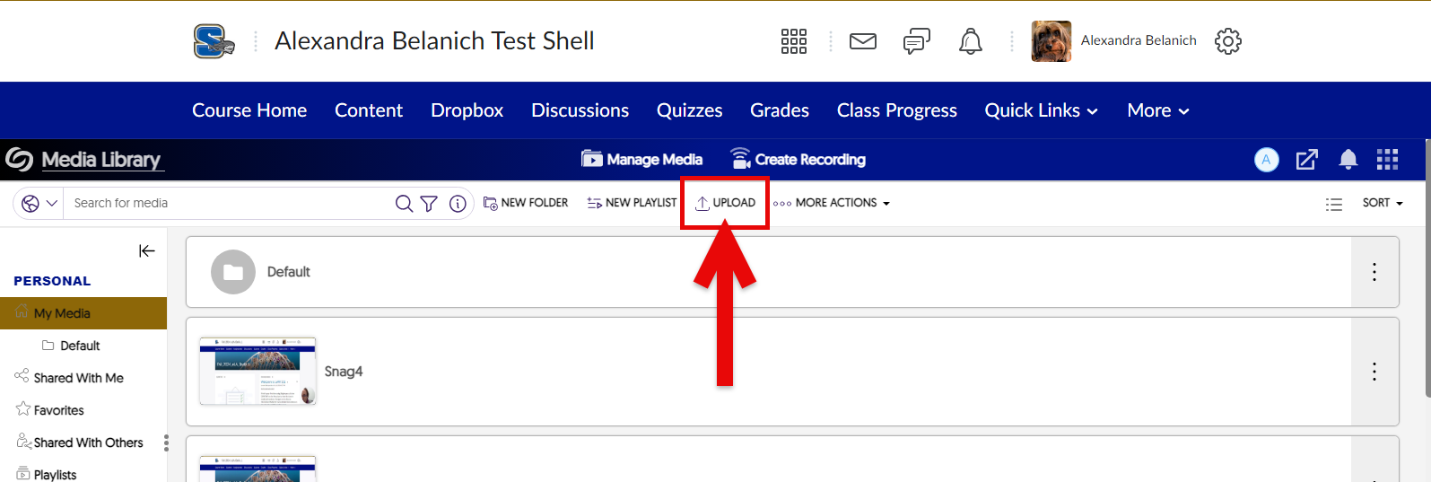
3. Before browsing to select your video, click on **Manage Captions**. Make sure that the captioning method is set to “Auto Caption” and that the language is set to the language that you want. The default is Auto Caption and American English. 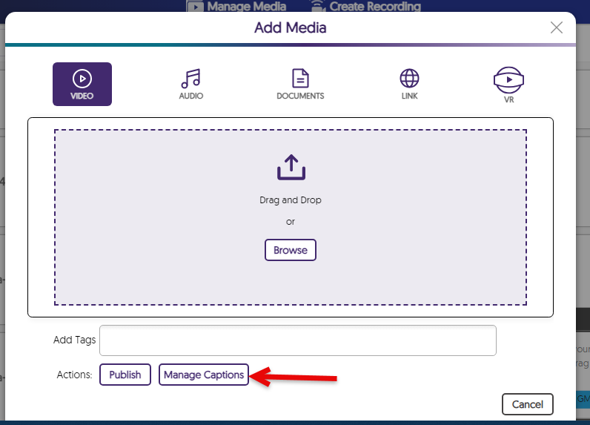  
     
   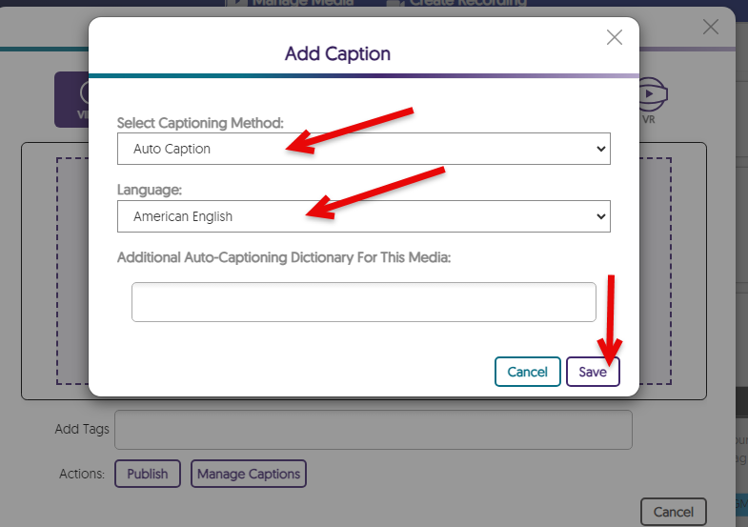
4. Click on **Browse**. In the file explorer select your video and then select Open. You’ll now be back in YuJa.
5. Once the video uploads, its thumbnail will appear. It might take a few minutes for it to process and for the captions to generate.
6. To edit the captions, click on the three dots to the right of your video (1) and select **Edit** (2).   
   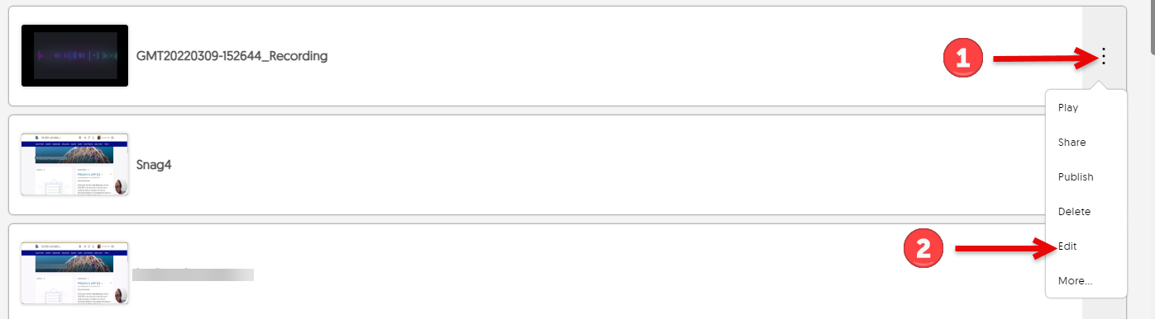
7. The YuJa video editor will launch. In the menu on the left, click on **Captions** (1) and then click into the text fields to edit them (2). When finished, click on **Save** (3). 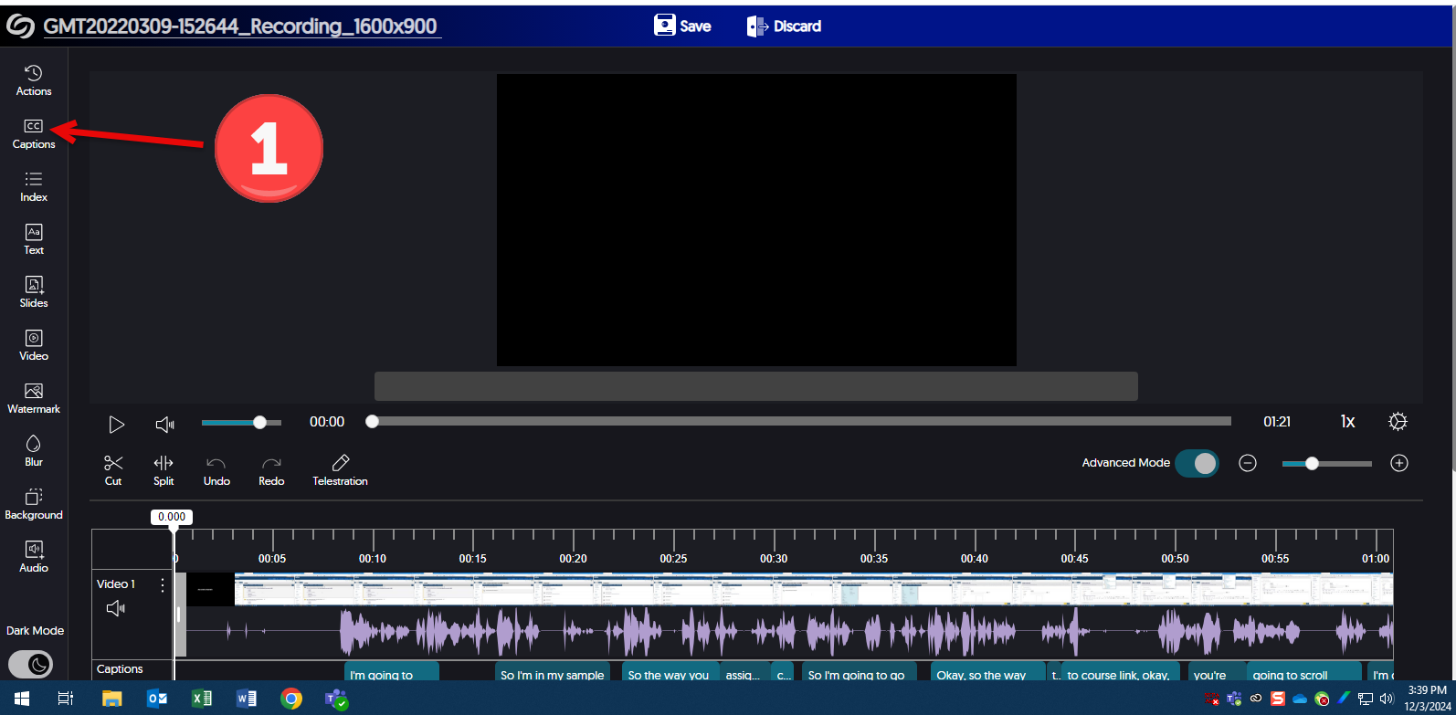  
     
   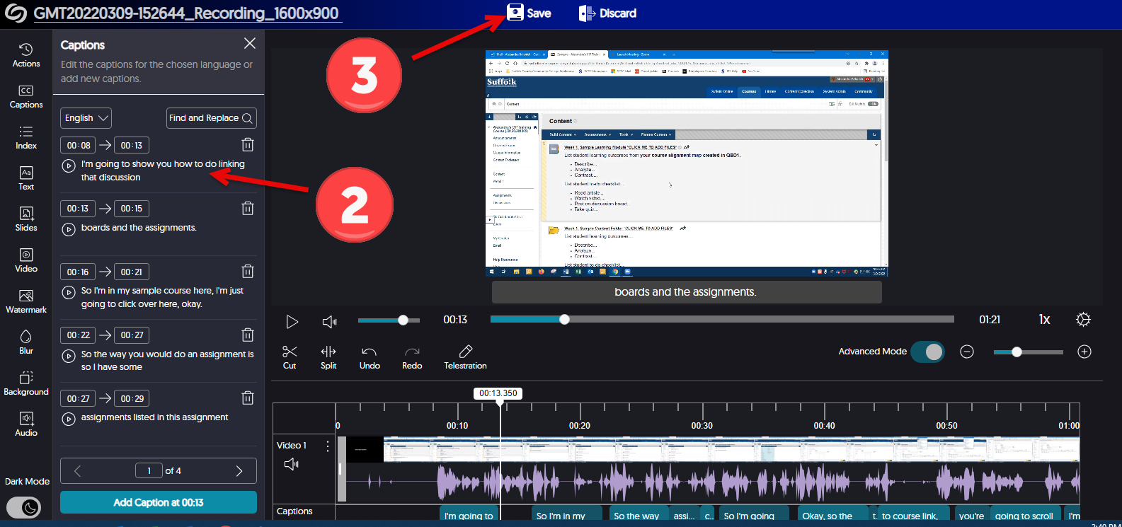
8. In the Save dialog box, select either “Replace Existing Video” or “Save as New Video.” “Save as New Video” will create a copy of the video with your edits.   
   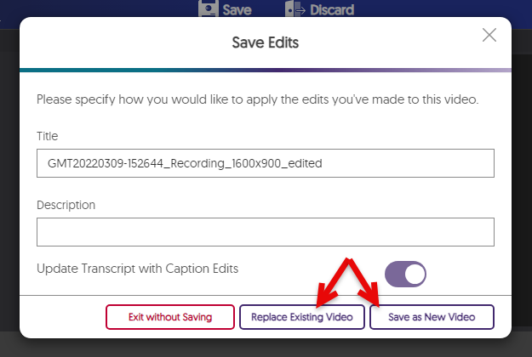
9. To share a link to your video, go to the thumbnail list of your videos, click on the three dots again, then select **More**. The Media Details dialog box will open. In the menu on the left, click on **Links**. Click on the button to the right of the link URL to copy the link. Click on the button to the right of the embed code to copy the embed code. The link or embed code can be put in your course. The link can also be shared in an email.   
   