# How to Change Course Start and End Dates

1. Log into [Brightspace](https://sunysuffolk.onelogin.com/client/apps/select/1169666692) with your *MySCCC* credentials.
2. On the *Brightspace* homepage, locate your course in one of the following ways:   
   * + Select on the course tile under the *My Courses*widget.
     + Select the **Course Selector Grid***https://carleton.ca/culearnsupport/students/wp-content/uploads/Screen-Shot-2020-11-02-at-8.15.40-PM.png*and select the course from the drop-down menu. If you are enrolled in more than 20 courses, you can search for the course name using the search bar.
3. In the navbar, select **Course Tools. If Course Tools option is not visible select More, and then Course Tools.**

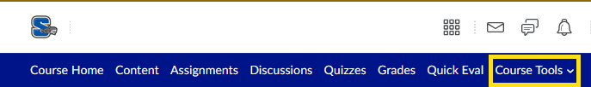

1. Select **Course Admin**.
2. Select **Course Offering Information**.

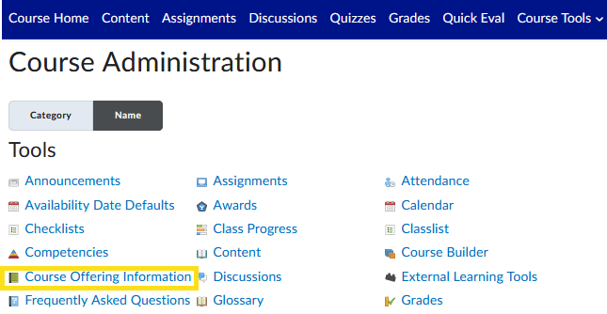

1. Scroll down the form until you find the label “Start Date” or “End Date”
2. Do not remove the check mark.
3. Click into the date box and enter the desired date and time.

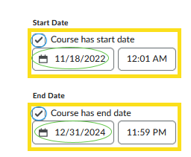

1. Click on the Save button.