Create an Accessible Table in Brightspace
Copying and pasting tables from Word to Brightspace will break the accessibility, even if formatting is removed when pasting the table into Brightspace. The remediation options in Brightspace are confusing and do not result in an accessible table.
These instructions will show how to create a table in Brightspace correctly from scratch, and also how to revise a table that was copied and pasted from Word to Brightspace.

Create a Table in Brightspace from Scratch
- In a module in Brightspace, create a Brightspace file by clicking on Upload/CreateCreate a File (Web Page).
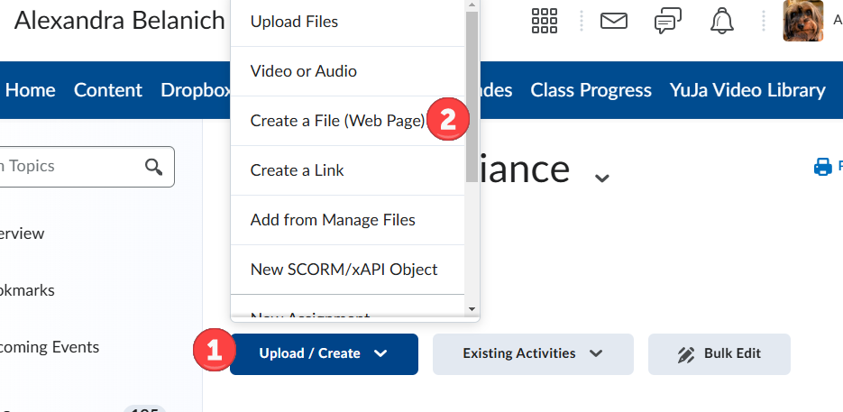
- In the Brightspace editor (text editor) click on the Table icon to insert a table.
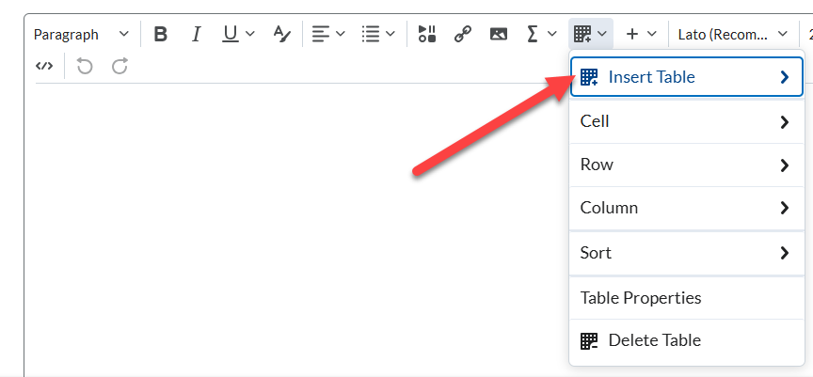
- Click and drag to select the number of rows and columns that you want.
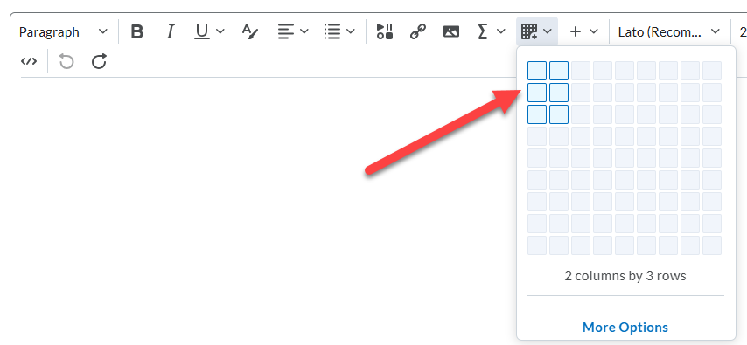
- Now that the table has been created, type directly into the cells or copy and paste the text from your table in Word into the cells. Important: If you are copying and pasting text from Word, be sure to choose Paste as Plain Text.
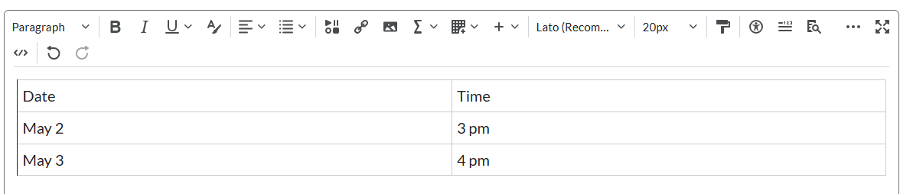
- To designate the first row as the header row, select the top row.
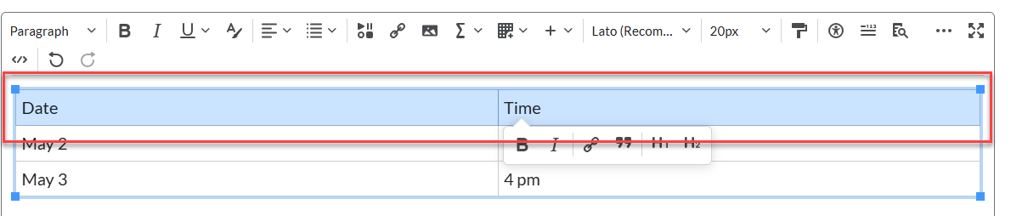
- With the top row selected, click on the Table icon again, then click on Cell. Important: Do not click on the mini-menu that pops up, as that will not have all these options. You must click on Table Properties in the menu bar.
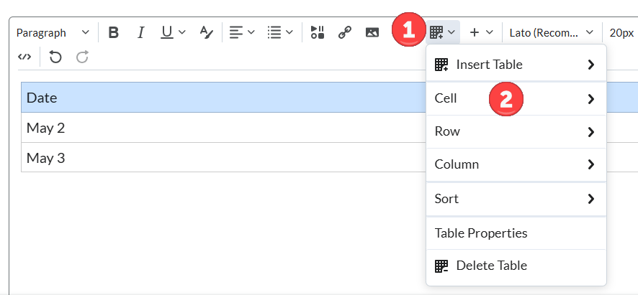
- Then, click on Cell Properties.
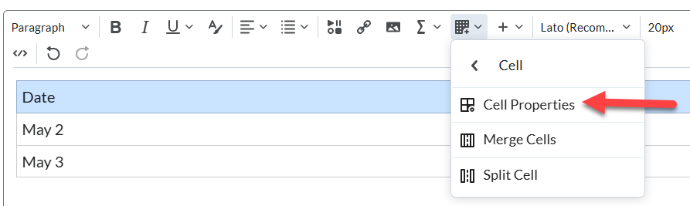
- Under Cell type, click on Header cell.
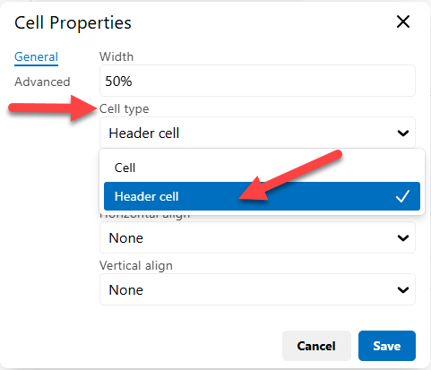
- Under Scope, click on Row.
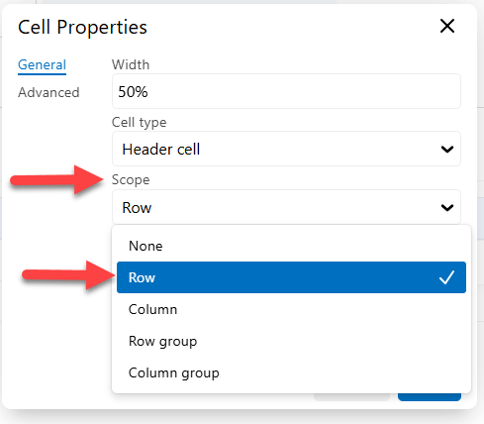
- The selections should look like this. After this, hit Save.
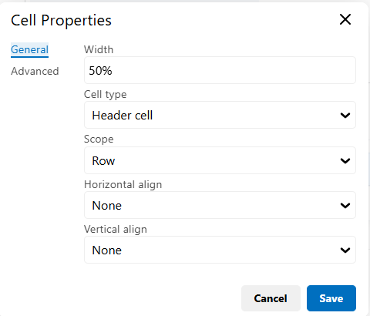
- You are not done yet! The table still needs a caption. Click on the Table icon again and this time select Table Properties.
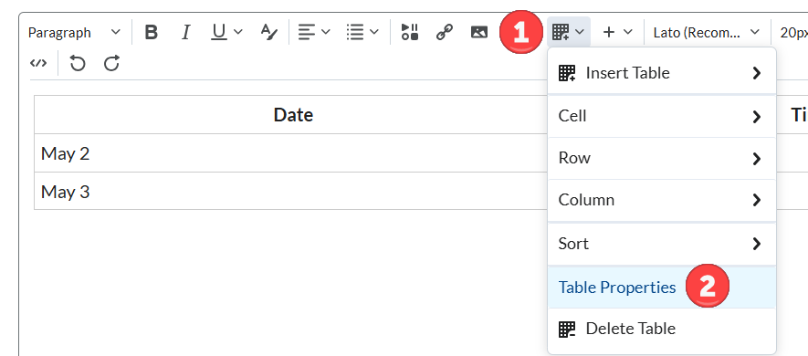
- In Table Properties, check the box Show caption, then hit Save.
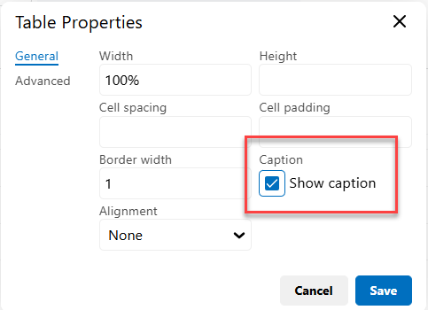
- A caption field will appear above the table. Edit this with the title or description of the table.
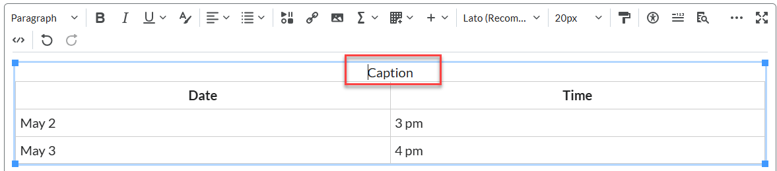
- When you are done, click on the accessibility icon to see if the table passes the accessibility check.
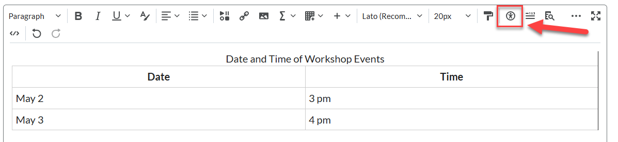
- There should be no accessibility issues detected. Congratulations!
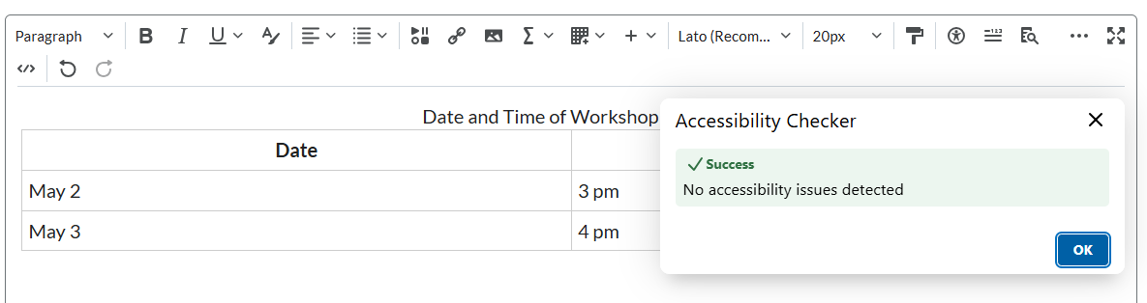

Revise a table in Brightspace that was copied and pasted in from Word
The table in this example was fully accessible in Word. However, in Brightspace, the Ally checker shows a perfect accessibility score, but the accessibility icon inside the text editor shows that there are four accessibility issues. This could be due to a difference in the analysis of the two accessibility checkers.
1 Screenshot of Ally checker showing perfect score.
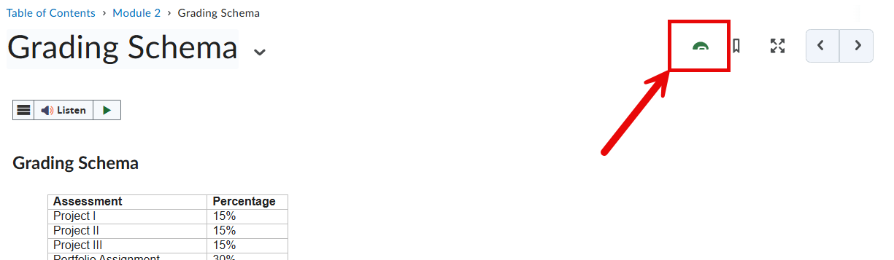

2 Screenshot of the text editor showing there are accessibility issues.
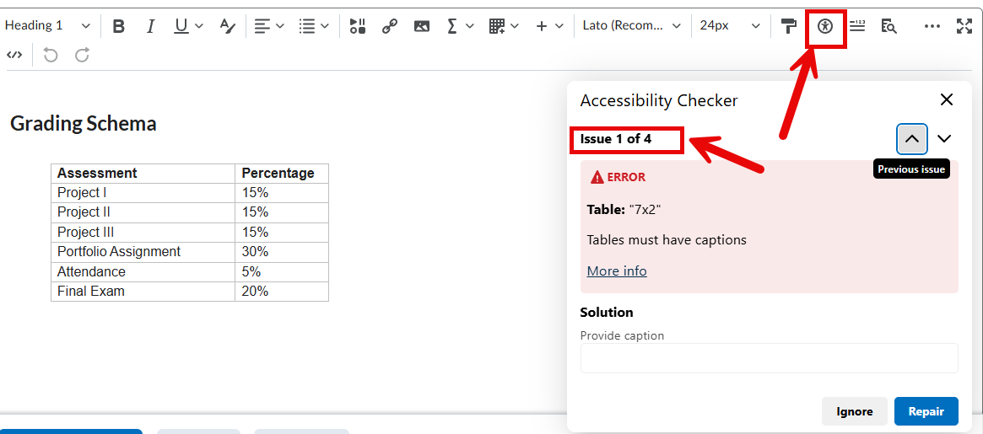

To revise pasted in tables, do the following:
- Copy a table from Word and select either Remove formatting or Keep formatting. It doesn’t matter which you choose because you’ll need to revise it anyway.
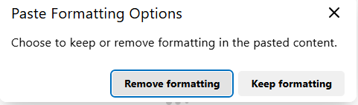
- Go ahead and click on the accessibility checker icon in the menu bar. Add the caption, and click Repair. Important: Scroll through the rest of the options and ignore any regarding headings or headers. You will fix these in the next step.
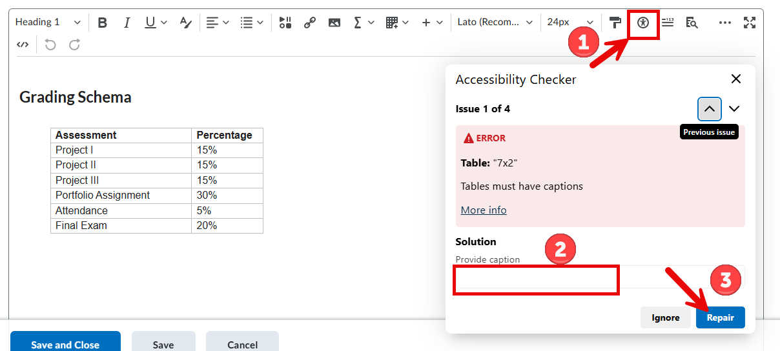
- To fix the header row, complete steps 6 to 10 in the first section of this document. When you’re done, click on the accessibility checker again to see if the issues have been resolved.

