

Using Publisher’s Online Instructional Content, such as eTextbooks
As per Academic Affairs (see College Brief 42, December 2016), all publisher sites must be integrated with the current SCCC Learning Management System (LMS). Classroom faculty must integrate the publisher content into the learning management system, currently D2L Brightspace.

Using the College’s Learning Management system ensures compliance with the Family Educational Rights and Privacy Act (FERPA), the Americans with Disabilities Act (ADA), and Middle States in the delivery of courses. The current LMS must be utilized to deliver all web-enhanced courses, classroom-based courses with online activities, as well as hybrid and fully online courses.

Instructions
To integrate your publisher site with the current College LMS, you will need to first configure the materials in the publisher site. All instructors should speak to their publisher representative about setting up their publisher sites. Next, instructors will need to insert a link to the publisher site in their SCCC LMS course content module. Currently, that means creating a Brightspace module, and creating and inserting a link to the publisher site using the Existing Activities button.

Brightspace Instructions

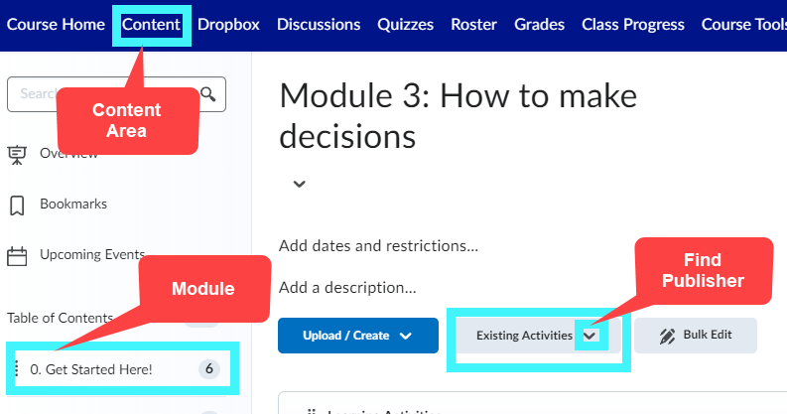

- Log into your course.
- Go to Content.
- Create a Module or select an existing module. You may label it: “Textbook.”
- Click on Existing Activities.
- Select your publisher.
- Follow the prompts.
- Contact the publisher help desk with any questions regarding the imported or linked content.
- See the list of publisher links below.

Links in Brightspace “Existing Activities” Button
The following are links that have already been installed in Brightspace for instructor use. If you do not see your publisher link in the list, click on External Learning Tools and review new list.

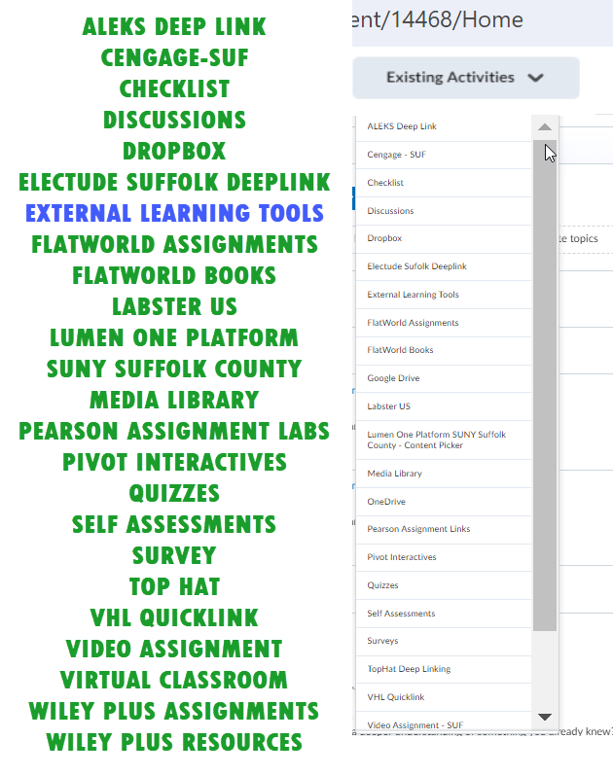
If you still can’t locate your publisher link, please contact the publisher and ask them for directions.

Last updated May 2024 by CTL. Questions? Email CTL@sunysuffolk.edu

